Project Design Phase-II Technology Stack (Architecture & Stack)

Date | 8 March 2026
Team ID | 699d5fd13074df695bbbb146
Project Name | AI-Powered Customer Support & Service Automation
Maximum Marks | 4 Marks

Technical Architecture:
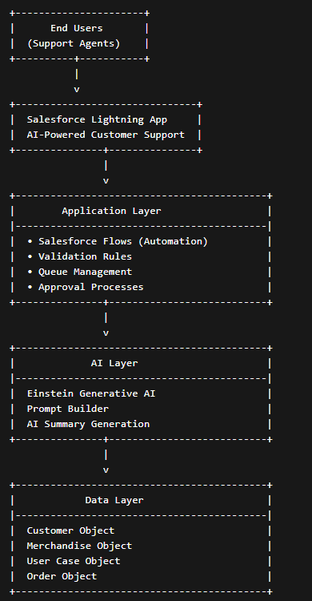

Table-1 : Components & Technologies:

S.No | Component | Description | Technology
1 | User Interface | Interface used by customers and support agents | Salesforce Lightning App Builder
2 | Application Logic | Handles case creation and automation workflows | Salesforce Flow
3 | AI Processing | Generates summaries and AI responses | Salesforce Einstein / Agentforce
4 | Case Management | Manages customer support tickets | Salesforce Service Cloud
5 | Database | Stores customer, product, and case data | Salesforce CRM Database
6 | Cloud Platform | Cloud hosting and application deployment | Salesforce Cloud
7 | File Storage | Stores attachments and case files | Salesforce File Storage
8 | External API | Integrates external services if required | REST APIs
9 | Reporting Engine | Generates reports and dashboards | Salesforce Reports & Dashboards
10 | Security Layer | Controls user authentication and permissions | Salesforce Security Model
11 | Infrastructure | Application deployed on cloud environment | Salesforce Cloud Infrastructure

Table-2: Application Characteristics:
S.No | Characteristics | Description | Technology
1 | Open-Source Frameworks | Frameworks used for system integration | REST APIs
2 | Security Implementation | Role-based access, authentication, and data protection | Salesforce Security, OAuth
3 | Scalable Architecture | Cloud-based scalable architecture | Salesforce Cloud Platform
4 | Availability | High availability cloud infrastructure | Salesforce Cloud
5 | Performance | Optimized automation flows and AI processing | Salesforce Flow
6 | Scalability | Supports growing customer support requests | Cloud-based CRM

